AUTOMATIC BODY MASS INDEX CALCULATOR- A PROTOTYPE MODEL

|  |  |
| --- | --- |
| **A MINI PROJECT REPORT** | |
| ***Submitted by*** | |
| **DARJAN SINGH N** | **(92132223028)** |
| **GOKULNATH M** | **(92132223041)** |
| **JEEVANANDHAM M**  **HARIHARAN S** | **(92132223060)**  **(92132223302)** |

***In partial fulfilment for the award of the degree of***

# BACHELOR OF TECHNOLOGY

**in INFORMATION TECHNOLOGY**

## PSNA COLLEGE OF ENGINEERING AND TECHNOLOGY,

**DINDIGUL.**

**(*An Autonomous Institution Affiliated to Anna University, Chennai)***

**MAY 2025**

## PSNA COLLEGE OF ENGINEERING AND TECHNOLOGY, DINDIGUL

***(An Autonomous Institution Affiliated to Anna University, Chennai)***

# BONAFIDE CERTIFICATE

Certified that this mini project report on **AUTOMATIC BODY MASS INDEX CALCULATOR- A PROTOTYPE MODEL** is the bonafide work of Mr. DARJAN SINGH N (92132223028), Mr. GOKULNATH M (92132223041), Mr. JEEVANANDHAM M (92132223060), Mr. HARIHARAN S (92132223302 ), who

carried out the mini project work under my supervision.

## SIGNATURE SIGNATURE

**Dr.A.VINCENT ANTONY KUMAR, Dr.B. MATHANKUMAR Asst. Prof, M.E,Ph.D., M.E,Ph.D.,**

## HEAD OF THE DEPARTMENT SUPERVISOR,

Department of Information Technology, Department of Information Technology, PSNA College of Engineering & Technology PSNA College of Engineering&Technology, Kothandaraman Nagar, Dindigul -624 622. Kothandaraman Nagar, Dindigul -624 622.

### Submitted for the Mini project viva-voce examination held on 2025

**Internal Examiner External Examiner**

# ACKNOWLEDGEMENT

We express our deep gratitude to Lord Almightly, our supreme guide for bestowing his blessings upon entire endeavor.

We take this opportunity to express our sincere thanks to the respected Chairperson **Tmt. K. DHANALAKSHMIAMMAL,** who is the guiding light for all the activities in our college. I would like to express our gratitude to our Pro- Chairman **Rtn.Thiru R.S.K. RAGURAM,** for their continuous support towards the student’s development.

Our heartful gratitude and respect go to our Principal, **Dr.D. VASUDEVAN M.E.,Ph.D.,**for his wholehearted support and help in the completion of our project

We are extremely thankful to **Dr. A. VINCENT ANTONY KUMAR M.E,Ph.D.,** professor and Head, Department of Information Technology for his valuable suggestions and encouragement in the completion of our project work.

We convey our grateful thanks to our **Coordinator Mr.Dr.W.R.SALEM JEYASEELAN.M.E.Ph.D.,** and our **Guide Dr. B. MATHANKUMAR. Asst. Prof. M.E,Ph.D.,** Information Technology department, for her innovative suggestion and valuable guidance. Finally, we thank all the teaching and non-teaching staff, our family, friends and well-wishers for their moral support that helped us in completing this work successfully.

# ABSTRACT

Body Mass Index (BMI) is a widely used metric for assessing an individual's body weight relative to their height, providing a quick and cost-effective method for identifying potential health risks such as obesity, malnutrition, and cardiovascular diseases. Traditionally, BMI is calculated manually using the formula. This method, although simple, is prone to human error and requires accurate input of height and weight, which can be inconvenient, especially in high- volume healthcare settings or for individuals with mobility issues. The drawbacks of this approach include, inaccuracy due to manual input errors time-consuming, especially in clinical settings Inaccessibility for people with disabilities or in rural areas lacking medical personnel. To address these limitations, we propose the development of an automated BMI calculator, which utilizes embedded sensors to measure height and weight without the need for manual intervention. This system can instantly calculate BMI and display or transmit the data for further analysis or storage. Our proposed automated system integrates Load Cell Sensor, Ultrasonic Sensor and Microcontroller Unit. An ultrasonic sensor is mounted above the user to capture height. When a user steps onto the platform, the system simultaneously records weight and height, calculates BMI and displays the result. This ensures speed, accuracy, and ease of use.

|  |  |  |
| --- | --- | --- |
|  | **TABLE OF CONTENTS** |  |
| **CHAPTER** | **TOPICS** | **PAGE** |
| **NO.** |  | **NO.** |
|  | **ABSTRACT** | **iv** |
|  | **LIST OF FIGURES** | **viii** |
|  | **LIST OF TABLES** | **ix** |
| **1.** | **INTRODUCTION** | **1** |
|  | 1.1. INTRODUCTION | 1 |
|  | 1.2. BACKGROUND | 2 |
|  | 1.3. BODY MASS INDEX | 3 |
|  | * 1. PROBLEM DISCUSSION      1. Identified Problems With Current Methods      2. Real-world Challanges | 4 |
| 4 |
| 4 |
|  | 1.5. OBJECTIVE | 5 |
| 1.5.1 Specific Objectives | 5 |
| **2** | **LITERATURE REVIEW** | **6** |
|  | 2.1. PROBLEM DEFINITION | 6 |
|  | 2.2. LITERATURE SURVEY | 6 |
| **3** | **PROPOSED SYSTEM** | **11** |
|  | 3.1. PROPOSED WORK | 11 |
| 3.1.1 Block Diagram | 12 |
| 3.2. WORK FLOW | 13 |

* 1. THE ARCHITECTURAL DESIGN 14
     1. Pin connection 15
  2. ADVANTAGES 16
  3. APPLICATIONS 17

1. METHODOLOGY 18
   1. NEED FOR NEW METHODOLOGY 18
      1. Process 18
   2. REQUIREMENTS 20
      1. Hardware description 20
      2. ESP32 20
      3. Load Cell Sensor 21
      4. Ultra Sonic sensor 22
      5. Battery and snap 22
      6. Other components 23
      7. Software description 24
   3. EXPERIMENTAL PROCEDURE 26
2. RESULT AND DISCUSSION 27
   1. PERFORMANCE SYSTEM 27
3. CONCLUSION AND FUTURE ENHANCEMENT 29
4. REFERENCE 30

**LIST OF FIGURES**

|  |  |  |
| --- | --- | --- |
| **FIGURE NO.** | **NAME** | **PAGE NO.** |
| 1.1 | BMI Samples | 3 |
| 3.1 | Block Diagram of the Proposed System | 12 |
| 3.2 | Architectural Design of the Proposed System | 14 |
| 4.1  4.2  4.3  4.4  4.5  4.6  5.1  5.2 | ESP32ESP32  Load Cell Sensor (HX711) Ultrasonic Sensor (HC-SR04) Battery  Snap  Arduino Code Proposed System  Output In Serial Monitor | 21  22  22  23  23  26  27  28 |

**LIST OF TABLES**

|  |  |  |
| --- | --- | --- |
| **TABLE NO.** | **NAME** | **PAGE NO.** |
| 1.1 | BMI Range and its Conditions | 3 |
| 3.1 | Pin connection (Loadcell sensor and ESP32) | 15 |
| 3.2 | Pin connection (Ultrasonic sensor and ESP32) | 16 |

# CHAPTER 1 INTRODUCTION

## INTRODUCTION

In the modern era, health awareness is becoming increasingly important due to the rapid rise in lifestyle-related diseases such as obesity, hypertension, and diabetes. One of the most commonly used indicators to assess an individual's body composition and health status is the Body Mass Index (BMI). BMI is calculated by dividing a person's weight in kilograms by the square of their height in meters. Although the formula is simple, accurate measurement and manual calculation can sometimes be time-consuming and error-prone, especially in public health screenings or busy clinical environments.

To address this problem, the Automatic BMI Detector mini project presents an innovative and practical solution by integrating commonly used sensors with a microcontroller to automate the BMI measurement process. The system uses a load cell sensor with an HX711 amplifier to measure the weight of the user, and an ultrasonic sensor to measure height. These two measurements are processed by an ESP32 microcontroller, which then calculates the BMI using the standard formula. The results are displayed either on an OLED screen or via a serial monitor, depending on the setup.

This mini project demonstrates the effective use of embedded systems and sensor integration in the field of biomedical applications. By automating the BMI calculation, the device can help reduce human errors, improve efficiency, and encourage users to track their health regularly. The system is cost-effective, easy to assemble, and scalable, making it suitable for use in homes, gyms, clinics, and health camps.

Furthermore, this mini project highlights how Internet of Things (IoT) technologies can be leveraged in the field of personal health monitoring. With future enhancements such as data storage, cloud connectivity, or mobile integration, this device could become a valuable

component of smart healthcare systems. Thus, the Automatic BMI Detector serves as a foundational step toward the development of compact, user-friendly, and intelligent health monitoring solutions.

## BACKGROUND

Body Mass Index (BMI) is a widely recognized health metric that relates a person’s weight to their height to assess body composition. The BMI value helps categorize individuals into various groups such as underweight, normal weight, overweight, or obese. This classification plays a vital role in health screening, early diagnosis of health risks, and fitness evaluation. While the BMI calculation is mathematically simple, it traditionally requires manual data entry, a calculator, and a measuring scale, which may not always provide consistent or accurate results, particularly in large-scale or real-time applications. With the advancement of sensor technologies and embedded systems, there is a growing interest in automating health assessment processes. Automation in BMI detection can eliminate human error, reduce time consumption, and improve accessibility, especially in environments like public clinics, gyms, schools, and remote health monitoring stations. The emergence of low-cost microcontrollers like the ESP32, along with accurate sensors such as load cells and ultrasonic sensors, has made it possible to build compact and affordable BMI measuring devices. The load cell, paired with an HX711 amplifier, allows for precise weight measurements. The ultrasonic sensor accurately determines height by measuring the distance from the sensor to the user’s head. By integrating these components with the ESP32, a reliable, efficient, and user-friendly system can be developed to calculate BMI automatically. This mini project builds upon fundamental concepts in electronics, biomedical instrumentation, and embedded systems to design a prototype model that can serve as a stepping stone toward smart health monitoring devices. It reflects the increasing intersection of healthcare and technology, where real-time, accurate, and automated data collection is becoming essential for proactive health

## BODY MASS INDEX

Body Mass Index (BMI) is a widely used method to assess whether an individual has a healthy body weight for a given height. It is a numerical value derived from a person's weight (in kilograms) divided by the square of their height (in meters). The BMI provides an easy, non-invasive, and cost-effective way to categorize individuals into various weight-related health groups.

𝑊𝐸𝐼𝐺𝐻𝑇(𝑘𝑔)

𝐵𝑀𝐼 = [HEIGHT(m)]^2

|  |  |
| --- | --- |
| BMI Range (kg/m²) | CONDITION OF BODY |
| Below 18.5 | Underweight |
| 18.5 – 24.9 | Normal weight |
| 25.0 – 29.9 | Overweight |
| 30.0 – 34.9 | Obesity Class I |
| 35.0 – 39.9 | Obesity Class II |
| 40.0 and above | Obesity Class III |

**TABLE 1.1**

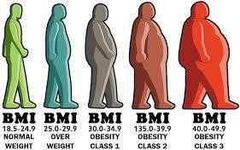

**BMI SAMPLES**

**FIGURE 1.1**

## PROBLEM DISCUSSION

Monitoring body health metrics such as Body Mass Index (BMI) is essential in today's world where lifestyle diseases are becoming increasingly common. Despite its importance, BMI is still often calculated manually in many health centers, fitness clubs, and homes. This traditional approach involves the use of separate equipment for weight and height measurements, followed by manual calculations, which can lead to inaccuracies, delays, and inconvenience—especially in settings that require mass screening or self- monitoring.

### Identified Problems with Current Methods:

Manual errors in recording height, weight, or BMI calculation. Lack of integration between height and weight measurement devices. Time- consuming process when used on a large number of people. Limited accessibility of reliable BMI measuring devices in rural or low-income areas. No data logging or digital display in many conventional system

### Real-world Challenges:

In health camps or government initiatives, where large numbers of people are screened, speed and automation are crucial.In the context of home fitness monitoring, people may not be trained to take accurate readings or interpret Biophysically challenged or elderly individuals may find it difficult to measure their height and weight separately. These issues highlight the need for an automated, reliable, and low-cost solution that can calculate BMI with minimal user intervention. This is where the proposed system—Automatic BMI Detector using ESP32, load cell, and ultrasonic sensor—offers a practical and innovative solution.

## OBJECTIVE

The objective of this mini project is to design and implement an Automatic BMI Detector using the ESP32 microcontroller, load cell, and ultrasonic sensor. The goal is to develop a compact, affordable, and user-friendly system that can calculate a person's Body Mass Index (BMI) automatically and display it in real- time.

### Specific Objectives

To measure body weight using a load cell sensor and HX711 amplifier. To detect a person’s height using an ultrasonic distance sensor. To use the ESP32 microcontroller to process the sensor data and calculate BMI.To display the BMI and corresponding health category on a serial monitor or OLED display. To build a low-cost, portable, and efficient system suitable for personal or clinical use. To reduce manual errors and increase accessibility of BMI measurement.

# CHAPTER 2 LITERATURE REVIEW

## PROBLEM DEFINITION

Body Mass Index (BMI) is a crucial health metric used to assess whether an individual has a healthy body weight for their height. However, traditional BMI measurement methods require manual input of weight and height values, typically using separate instruments such as weighing scales and stadiometers. These methods can be time-consuming, error-prone, and impractical for frequent use in community health programs, fitness centers, or remote areas lacking medical infrastructure. There is a need for a compact, automated, and cost- effective system that can accurately measure both weight and height and compute BMI without manual intervention. Additionally, the lack of portability and digital data storage in traditional systems limits their applicability in today’s health- conscious, tech-driven environment. To address these limitations, the proposed solution involves developing an automatic BMI detector using an ESP32 microcontroller, a load cell sensor for weight measurement, and an ultrasonic sensor for height detection. The system aims to provide real-time, accurate BMI values with minimal user effort, displayed conveniently on an LED screen or via a serial monitor.

## LITERATURE SURVEY

In this section the main objective is to understand the various terminologies related to the domain of interest and has done by visiting related online websites and various journal papers as discussed below.

Bernard Mark S. Baladad, Julius V. Magsombol, Joshua Nathaniel B. Roxas, Evelyn L. De Castro, and Joselito A. Dolot (2016) designed and developed

an automated BMI calculation device using ultrasonic proximity sensors, weight sensors, and microcontrollers (Gizduino ATMEGA328). The device successfully automated BMI calculation, providing accurate and fast results suitable for hospitals, schools, and fitness centers. However, it had limitations like inability to accommodate persons weighing above 90kg, and was unsuitable for individuals with dwarfism, disabilities, or mannerism movements.

Burhan Uddin Ismail, Syed Fahad Akbar Ali, and Ali Asghar Ayaz (2012) proposed a microcontroller-based automated BMI calculator using a load cell for weight measurement and an ultrasound sensor for height detection. The result was displayed on an LCD screen. Their system efficiently calculated BMI but did not directly assess body fat composition, making it less reliable for muscular individuals. Also, the accuracy of height measurement was sensitive to posture and sensor performance.

Dr. M. Kannan, K. Tharanitharan, A. Sreeba, Y. Nandhini, T. Pavithrakumar, and Ms. T. Akila (2017) presented an automated BMI calculator using a PIC16F877A microcontroller. Load cells and ultrasonic sensors were utilized for weight and height measurements, respectively. The system promoted healthy lifestyles and detected overweight conditions effectively but had limitations as BMI alone cannot distinguish between muscle and fat compositions.

S. Jasmine Minija and W.R. Sam Emmanuel (2019) proposed a health monitoring system that integrates BMI calculation with a calorie calculator using image processing and a feed-forward neural network. Their model achieved high accuracy in food recognition and calorie estimation but relied heavily on image quality, lighting conditions, and a limited food dataset, affecting real-world

Diky Andriansyah and Donny Avianto (2024) developed an Android-based BMI calculator and nutrition consultation application using a user-centered design approach. Their app successfully provided BMI calculations, personalized nutritional advice, and real-time consultations, though its application was limited by platform dependency and needed enhancements for broader adoption.

Israel Esan Owolabi, Vincent Andrew Akpan, and Olajide Patrick Oludola (2021) designed a low-cost automatic BMI machine using load-cell and ultrasonic sensors interfaced with an Arduino Mega 2560. The device demonstrated high accuracy compared to manual methods but lacked evaluations for long-term durability and faced challenges regarding reliance on BMI as a sole health indicator.

Ertie C. Abana et al. (2020) developed a BMI assessment machine using a microcontroller, integrating a load cell, ultrasonic sensor, keypad, and LCD. The system achieved 98.32% accuracy in BMI calculation and 100% success in classifying nutritional status. However, minor errors in height measurement and ideal weight suggestions highlighted areas for future refinement.

Ms. Varsha R. Mhatre, Mr. Prashant M. More, and Prof. S. S. Ayane (2015) built a microcontroller-based BMI calculator using a PIC 18F452. The device measured weight using a weighing machine and height via an LDR sensor, then processed results through a GSM module to users. While cost-effective, its accuracy was constrained by the sensor limitations and it lacked integration with

broader health metrics.

Olawuni Adeolu, Fapohunda Taiwo, Afonne Emmanuel, and Akanbi Lukman (2022) developed an automated BMI calculation system using Arduino with a load cell and ultrasonic sensor. Tested among students, the system achieved accurate results, although it could only accommodate one person at a time and faced slight errors due to human positioning during measurement.

Nenny Anggraeni, Nashrul Hakiem, and Gerry Widya Ganesha (2020) developed a calorie counter Android application using Rapid Application Development (RAD) methodology. The app included a BMI calculator, TDEE calculator, and food calorie tracker, providing an effective offline tool for diet management, but lacked cross-platform support and online database updates.

S. Aravinth and S. Sathishkumar (2020) proposed an IoT-based health monitoring system integrating BMI calculations along with blood pressure and temperature readings. Using ESP32 and cloud services, their mini project allowed remote monitoring but faced challenges related to real-time data synchronization and sensor calibration.

T. V. Sreelakshmi and R. Nishanthini (2019) designed a smart health monitoring device where BMI and basic vitals were calculated using microcontroller-based hardware and displayed on an OLED screen. Their device proved useful for rural and semi-urban healthcare but required improvements in compactness and battery management.

N. Vignesh and R. Mohanraj (2018) developed a wearable health band that could estimate BMI along with heart rate and oxygen saturation using multiple sensor inputs. Though innovative, the wearable's BMI estimation depended on user-inputted height, limiting true automation.

Deepika S. and V. Priyadarshini (2017) introduced a smart kiosk for BMI and body fat analysis using bio-impedance sensors. Although the system provided better insights into body composition compared to BMI alone, its cost was considerably higher, limiting accessibility for mass deployment.

M. Prachi and K. Saravanakumar (2017) worked on an Arduino-based BMI and weight monitoring system with real-time data logging to an SD card. Their mini project offered a simple and effective solution for periodic health tracking but required manual intervention for height entry, slightly reducing automation.

# CHAPTER 3 PROPOSED SYSTEM

The proposed method aims to develop an automatic BMI calculator that integrates load cell and height-sensing technology to provide real-time and accurate BMI measurements. The system eliminates the need for manual input, ensuring precision and ease of use.

## PROPOSED WORK

The proposed work aims to design and implement an Automatic BMI Detector that provides an efficient and non-invasive method to measure and calculate a person’s Body Mass Index using embedded system technology. The system integrates a load cell with an HX711 amplifier to measure the user's body weight and an ultrasonic sensor (HC-SR04) to measure the user's height. These sensors are interfaced with the ESP32 microcontroller, which serves as the core processing unit. The ESP32 collects the input from both sensors, processes the data, and calculates the BMI using the standard formula: BMI = weight (kg) / height² (m²). The calculated BMI value is then displayed either on an OLED screen or through the serial monitor for easy readability. Additionally, the system classifies the BMI based on WHO guidelines into categories such as underweight, normal, overweight, or obese. The device is designed to be portable, cost- effective, and user-friendly, with potential applications in personal healthcare monitoring, fitness centers, and clinics. The proposed design addresses limitations of traditional manual BMI measurements by automating the process and enhancing the accuracy and convenience of health assessment.

* + 1. **BLOCK DIAGRAM**

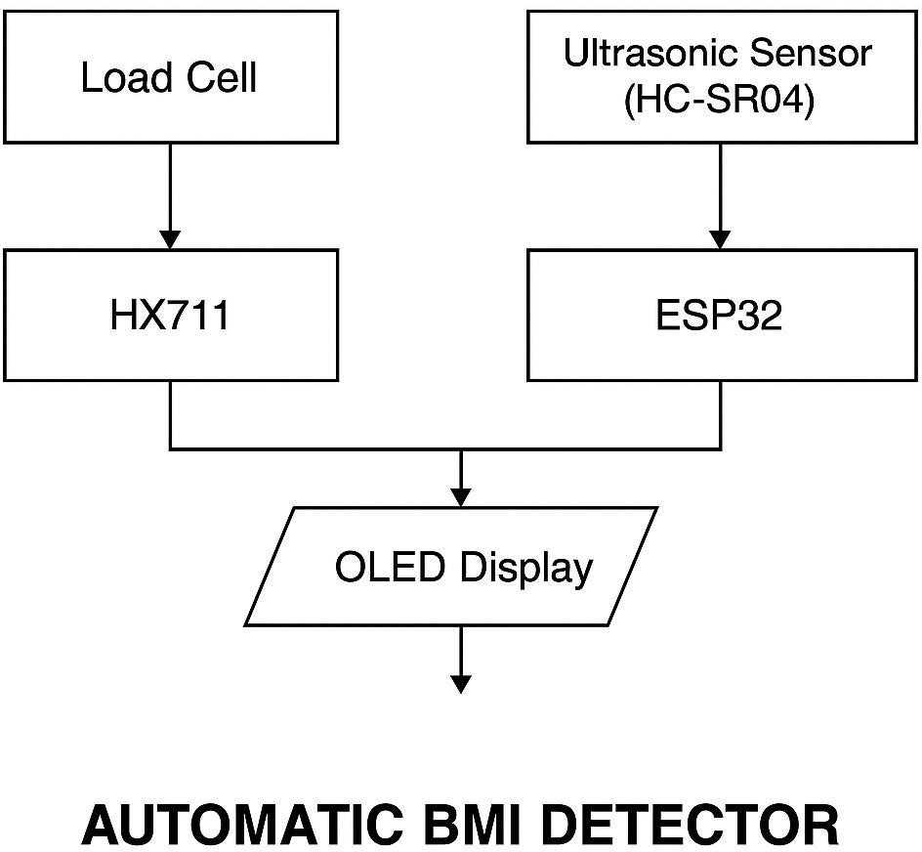

### Figure 3.1. Block Diagram of the proposed System

A brief explanation about the block diagram is given ahead.

The block diagram illustrates the interaction between the essential hardware components of the system, with the ESP32 microcontroller at its core. The process begins with two primary sensors:

**Load Cell Sensor (with HX711 Module):** This sensor measures the user’s weight when they stand on the platform. The HX711 module amplifies and converts the analog signal from the load cell into a digital signal that is sent to the ESP32 for further processing.**Ultrasonic Sensor (HC-SR04):** Positioned above the user, this sensor calculates the user's height by measuring the distance from the sensor to the top of the head. The measured value is converted into meters and sent to the ESP32.Once the ESP32 receives both the weight and height data, it performs calculations to determine the Body Mass Index (BMI) using the standard formula:

BMI = weight (kg) / height² (m²)

12

After calculating the BMI, the ESP32 classifies the result into categories such as underweight, normal, overweight, or obese based on WHO standards. The final BMI value and classification are then displayed in one of the two output options;**OLED Display:** A compact screen connected to the ESP32 that visually presents the BMI value.**Serial Monitor:** An alternative output where the BMI data is viewed on a computer via the Arduino IDE.

The system is powered either by a USB connection or a portable power supply, making it suitable for both mobile and fixed setups. This architecture ensures real-time, automated, and non-invasive BMI measurement for users in a variety of environments.

## WORK FLOW

The workflow of the proposed Automatic BMI Detector begins when the user steps onto a stable platform embedded with a load cell sensor, while positioning themselves beneath an overhead-mounted ultrasonic sensor. The load cell sensor, in conjunction with the HX711 amplifier, measures the user’s body weight and sends the data to the ESP32 microcontroller for processing. Simultaneously, the ultrasonic sensor captures the height by calculating the distance from the sensor to the top of the user's head. Both the weight and height values are converted into appropriate units — kilograms and meters, respectively — by the ESP32. Using these values, the microcontroller then calculates the Body Mass Index (BMI) using the standard formula: BMI = weight (kg) / height² (m²). Once the BMI is computed, the system classifies the result based on WHO guidelines into categories such as underweight, normal, overweight, or obese. The final BMI value and its corresponding category are then displayed on an OLED screen or viewed via the serial monitor, offering a quick and convenient health assessment. This seamless and automated workflow ensures efficiency, accuracy, and ease of use for regular BMI monitoring.

### The ARCHITECTURAL DESIGN

The architectural design of the proposed Automatic BMI Detector is centered around the integration of sensors with an ESP32 microcontroller to form a compact and intelligent health monitoring system. The system architecture begins with the load cell sensor, which is responsible for capturing the user's body weight. This sensor is connected to an HX711 amplifier module that converts the analog signal from the load cell into a digital signal, suitable for processing by the ESP32. Simultaneously, the ultrasonic sensor (HC-SR04) is used to measure the user's height by detecting the distance between the sensor and the user's head. Both sensor inputs are sent to the ESP32, which acts as the central processing unit.

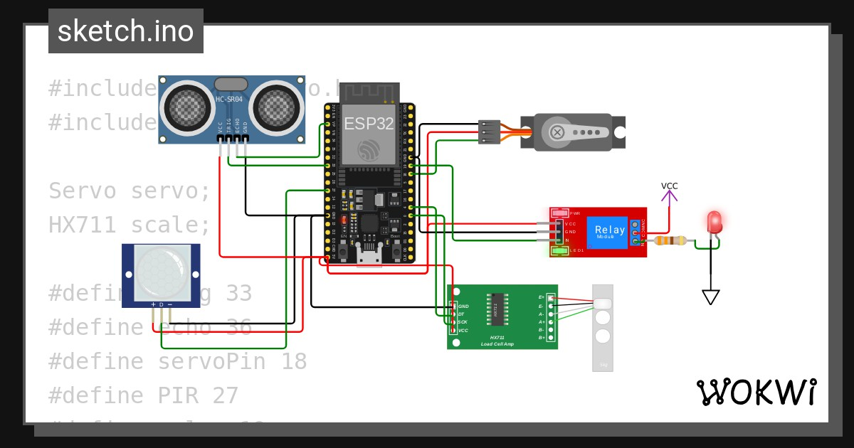

### Figure 3.2. Architectural Design of the proposed system

Once the ESP32 receives the weight and height data, it processes the information and applies the BMI formula (BMI = weight in kg / height² in m²) to compute the user's Body Mass Index. Following the calculation, the system evaluates the BMI value and classifies it into the appropriate health category based on WHO standards. The final result is displayed on an OLED display or serial monitor, providing immediate feedback to the user. The entire architecture is powered through a USB or battery source, making the system portable and

suitable for real-time use in personal or clinical settings. The modular design ensures easy integration, maintenance, and scalability for future upgrades, such as wireless data transfer or smartphone connectivity.

## PIN CONNECTION

The pin connection between the ESP32 and Load cell sensor and Ultra sonic sensor are tabulated below.

|  |  |
| --- | --- |
| **HX711(Load Cell Sensor)** | **ESP32** |
| VCC | 3.3V (HX711 works at 3.3V) |
| GND | GND |
| DT (Data) | GPIO23 |
| SCK (Clock) | GPIO19 |

### Table 3.1. Pin Connection (HX711(Load Cell Sensor) and ESP32)

|  |  |
| --- | --- |
| **HR-SR04 (Ultra Sonic Sensor)** | **ESP32** |
| VCC | 5V (or 3.3V if your module supports it) |

|  |  |
| --- | --- |
| GND | GND |
| TRIG | GPIO4 |
| ECHO | GPIO2 |

**Table 3.2. Pin Connection (HC-SR04 (Ultra Sonic Sensor) module and ESP32)**

## ADVANTAGES

* Body Mass Index (BMI) is calculated automatically using height and weight data.
* Accurate and contactless height measurement using the ultrasonic sensor.
* Weight is detected precisely using the load cell with HX711 amplifier.
* The ESP32 processes the sensor values and performs BMI calculation.
* The result is displayed on the serial monitor for easy monitoring and debugging.
* Can be expanded to display results on OLED/LCD or sent via Wi- Fi/Bluetooth to a mobile app.
* Useful for quick health monitoring in homes, clinics, and fitness centers.
* Battery or USB powered – portable and compact.
* Can be integrated into smart health IoT systems with cloud storage or alerts.

## APPLICATIONS

* Hospitals and Clinics – For quick BMI assessment of patients during routine check-ups.
* Gyms and Fitness Centers – To help clients track their body composition and monitor fitness progress.
* Schools and Colleges – For health check-up camps and awareness programs.
* Home Health Monitoring – Personal health tracking for individuals and families.
* Remote/Field Health Camps – Portable device for BMI screening in rural or remote areas.
* Smart Weighing Machines – Can be integrated into commercial smart scales or kiosks.
* IoT-Based Health Systems – Part of connected healthcare ecosystems that log BMI data to the cloud.
* Corporate Wellness Programs – For health screenings in offices and wellness drives.
* Insurance & Wellness Assessments – Quick BMI check for initial health profiling.

# CHAPTER 4 METHODOLOGY

## NEED FOR NEW METHODOLOGY

Traditional BMI calculation requires manual measurement of weight and height using scales and stadiometers, which is time-consuming, error-prone, and dependent on trained personnel. To overcome these limitations, this project proposes an automated system that uses sensors and an ESP32 microcontroller to measure, calculate, and display BMI in real time without any manual input. A load cell with an HX711 amplifier accurately measures weight, while an ultrasonic sensor (HC-SR04) determines height by calculating the distance from the sensor to the top of the user's head. The ESP32 processes the sensor data and calculates BMI using the formula. The result is displayed via the serial monitor and can be extended to other outputs like OLED displays or mobile interfaces. This smart system ensures speed, accuracy, and ease of use, making it ideal for clinics, gyms, health camps, and home use—promoting accessible and healthcare.

## PROCESS

### User stands on the load cell:

The system is activated when the user steps onto the platform containing the load cell sensor.

### Weight measurement begins:

The load cell measures the body weight and sends analog data to the HX711 module, which converts it to digital.

### ESP32 receives weight data:

The ESP32 reads the digital weight value from the HX711 module.

### Ultrasonic sensor measures height:

The HC-SR04 sensor emits ultrasonic waves and calculates the height based on the time it takes for the wave to reflect from the user's head.

### ESP32 receives height data:

The measured distance is converted into height (by subtracting from a fixed reference height, like ceiling-to-platform).

### BMI is calculated:

ESP32 uses the formula:

BMI = weight (kg) / [height (m)]²

### Result is displayed:

The BMI value is shown on the serial monitor or can be sent to an OLED display or mobile app.

### Optional feedback:

Based on the BMI result, the system can give comments (e.g., "Underweight", "Normal", "Overweight", "Obese") and optionally send SMS or alert.

## REQUIREMENTS

The major components used for the design of the system are listed. The proposed design requires the following hardware and software components.

1. Hardware requirements
   * ESP32
   * Load Cell Sensor(HX711)
   * Ultra Sonic Sensor(HC-SR04)
   * Bread board
   * Jumper wires
   * Cable
2. Software requirements
   * Arduino IDE
   * Serial monitor

## HARDWARE DESCRIPTION

The following section deals with the requirements for the work and the illustration of the hardware components used in the work.

## ESP32

The ESP32 is a powerful microcontroller with built-in Wi-Fi and Bluetooth capabilities. It is the brain of the BMI detector system. It reads data from sensors, performs calculations (like BMI), and handles outputs such as displaying results or sending data to other devices. It has multiple GPIO (General Purpose Input/Output) pins and supports both digital and analog inputs. Its fast processing and connectivity features make it ideal for IoT and health monitoring mini projects.

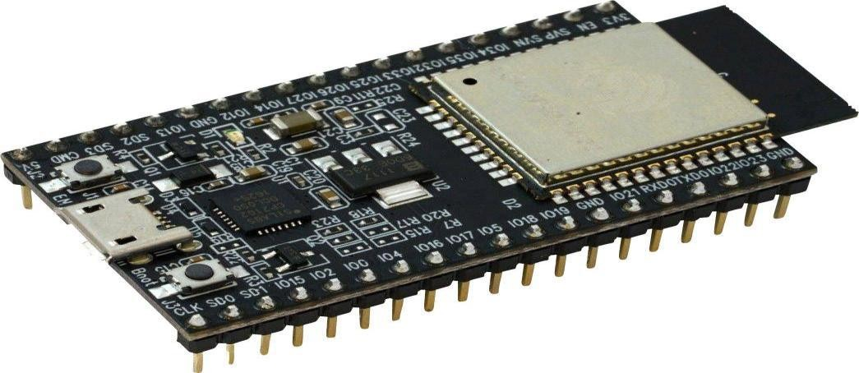

### Figure 4.1. ESP32

* + 1. **Load Cell Sensor (HX71):**

The Load Cell is a sensor that measures weight or force. When a person stands on the load cell, it bends slightly and changes its electrical resistance. This change is very small, so it’s connected to an HX711 module, which is a precision 24-bit analog-to-digital converter (ADC) designed specifically for weighing scales. HX711 amplifies and converts the tiny signal from the load cell into a digital signal that the ESP32 can read accurately.



### Figure 4.2. Load Cell Sensor (HX711)

* + 1. **Ultrasonic Sensor (HC-SR04):**

The HC-SR04 Ultrasonic Sensor is used to measure height by determining the distance between the sensor and the top of the user's head. It works by emitting ultrasonic sound waves and measuring how long it takes for the echo to return after bouncing off an object. This time is converted into distance using the speed of sound. By placing the sensor above the user and knowing the fixed height from the sensor to the ground, the person’s height can be calculated by subtracting the measured distance.

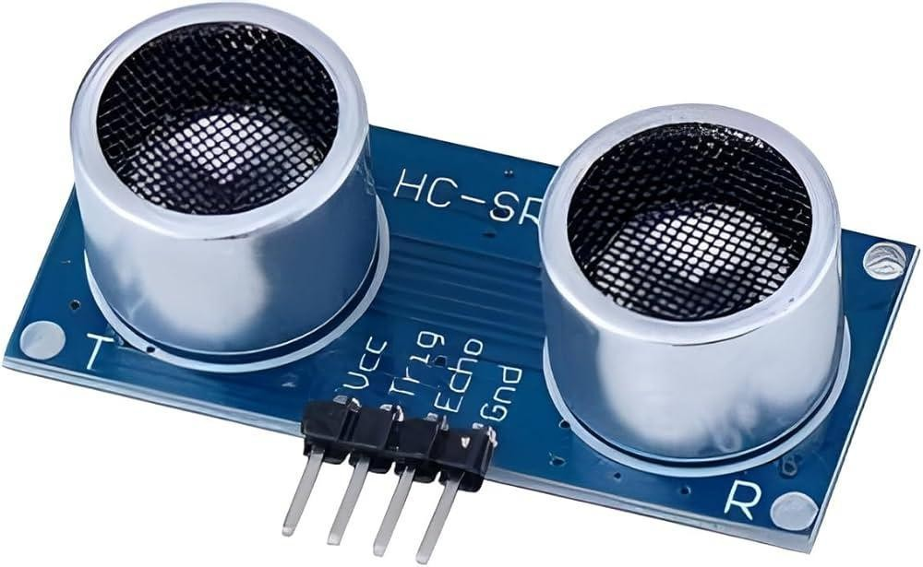

### Figure 4.3. Ultrasonic Sensor (HC-SR04)

## BATTERY AND SNAP

Battery is a source of electric power consisting of electrochemical cells with external connections for powering electrical devices. The nine-volt battery is an electric battery that supplies a voltage of 9 volts. It features a rectangular prism shape that utilizes a pair of snap connectors which are located at the top of the battery.



### Figure 4.4. Battery

Snap or connector is used to connect the battery to the circuit. It is connected based on the +ve and -ve terminal.

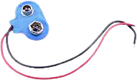

**Figure 4.5. Snap**

## 4.2.6 OTHER COMPONENTS

A jumper wire is an electrical wire with pin at each end (or sometimes without them-simply tinned) which is normally used to interconnect the components of a breadboard. There are different types of jumper wires. Some have the same type of electrical connecter at both ends, while others have different connectors. Some common connectors are: solid tips, crocodile clips, banana connectors, registered jack, RCA connectors, RF connectors. The pin head of the jumper cable may be male or female.

Bread board is used for building temporary circuits. It is useful for designing prototype model of the any mini project ideas. Unlike a [perfboard or](https://en.wikipedia.org/wiki/Perfboard) [stripboard,](https://en.wikipedia.org/wiki/Stripboard) breadboards do not require [soldering](https://en.wikipedia.org/wiki/Soldering) or destruction of tracks and are hence reusable. For this reason, breadboards are also popular with students and in technological education.

Cable (USB Cable) for ESP32 connects the pc or other devices with the ESP32 for uploading program into the ESP32 board. Cable For ESP32 is the most common A to B Male/Male type peripheral USB cable for ESP32.

## 4.1.7. SOFTWARE DESCRIPTION

The **Arduino IDE** is the primary software used for programming the **ESP32 microcontroller** in the Automatic BMI Detector mini project. It provides a simple text editor for writing the code (called a *sketch*) and includes tools to compile and upload the program to the ESP32 via USB connection. This IDE supports C and C++ programming languages and is compatible with multiple platforms including Windows, Mac OS, and Linux. In this mini project, the Arduino IDE is used to write the code that reads data from the **HX711 load cell module** and **HC-SR04 ultrasonic sensor**, processes the input, and calculates the BMI. The written sketch is saved with the .ino file extension and uploaded to the ESP32 for execution.

The **Serial Monitor**, a built-in feature of the Arduino IDE, is used to display the output in real-time. It allows you to monitor sensor readings, BMI calculations, and test/debug the system during development. This makes it an essential tool for both programming and verifying the functionality of the mini project.

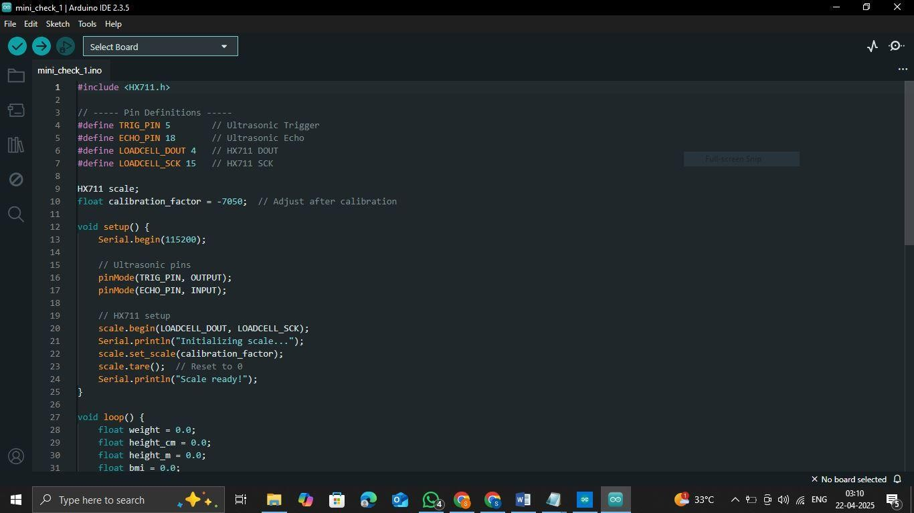

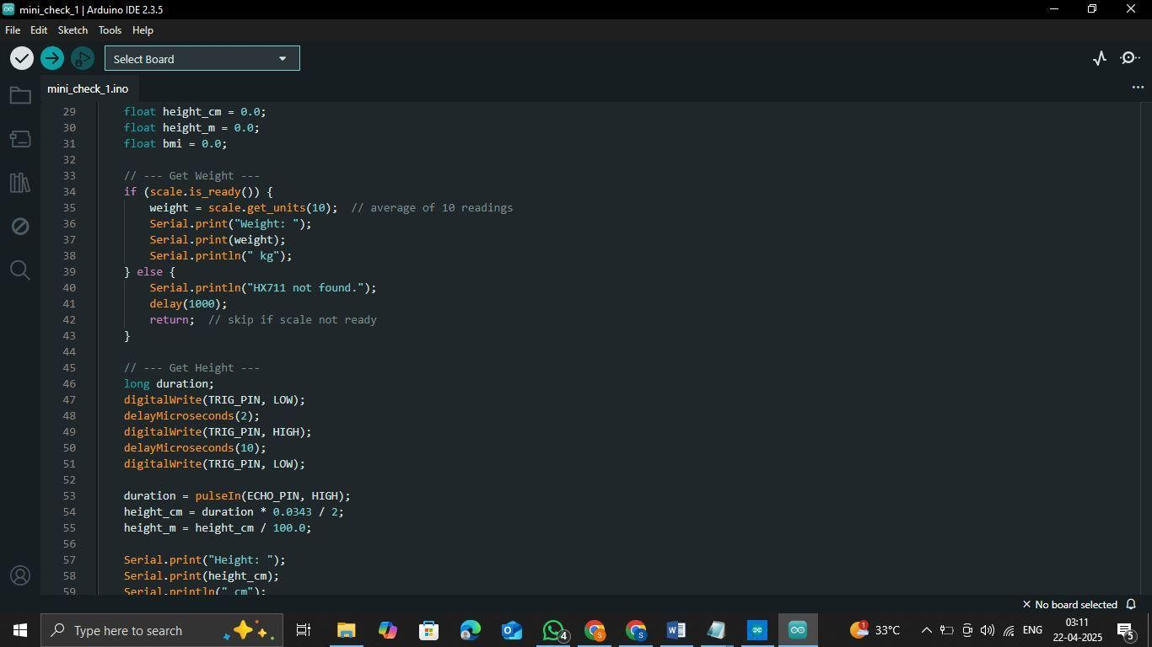

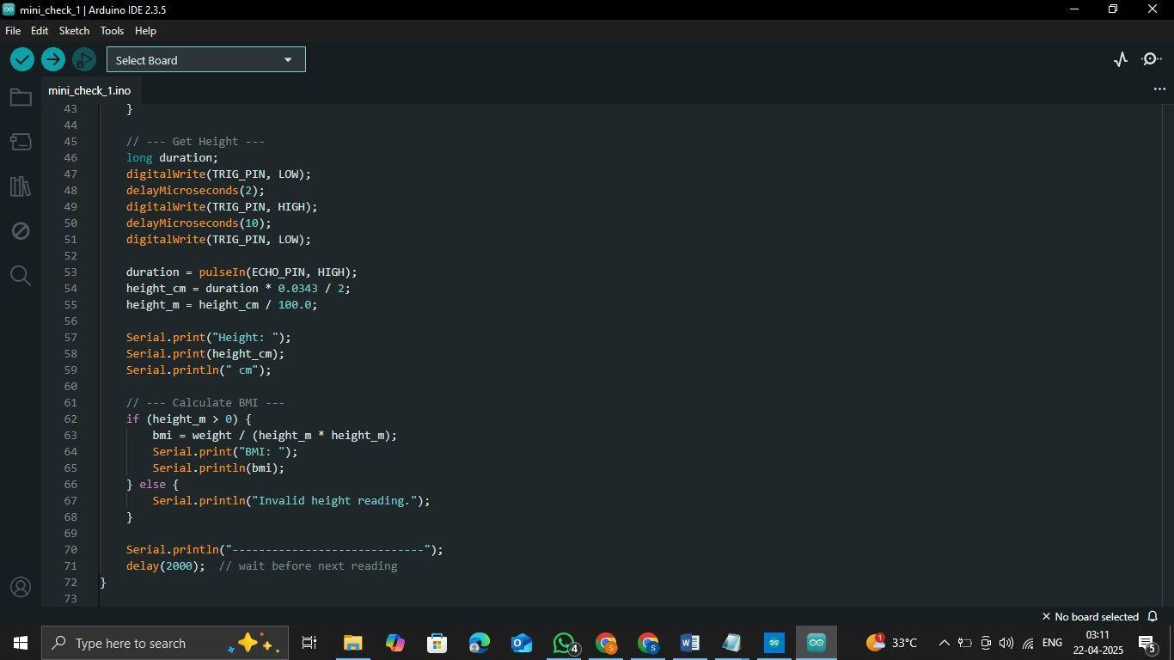

**Figure 4.6 Arduino code**

## EXPERIMENTAL PROCEDURE

The following steps were done for testing the non-invasive glucometer device

The person was asked to stand on the load cell platform placed directly below the ultrasonic sensor. The load cell detected the person's weight, and the value was sent to the HX711 amplifier. The amplified signal was transmitted to the ESP32 microcontroller. Simultaneously, the ultrasonic sensor (HC-SR04) measured the height by calculating the distance from the sensor to the top of the person’s head. The ESP32 received both weight and height values and calculated the BMI using the formula: BMI = weight (kg) / height (m)².The calculated BMI was then sent to the Serial Monitor through the Arduino IDE for display. The accuracy of the BMI reading was verified using manual calculations for comparison.

# CHAPTER 5 RESULT AND DISCUSSION

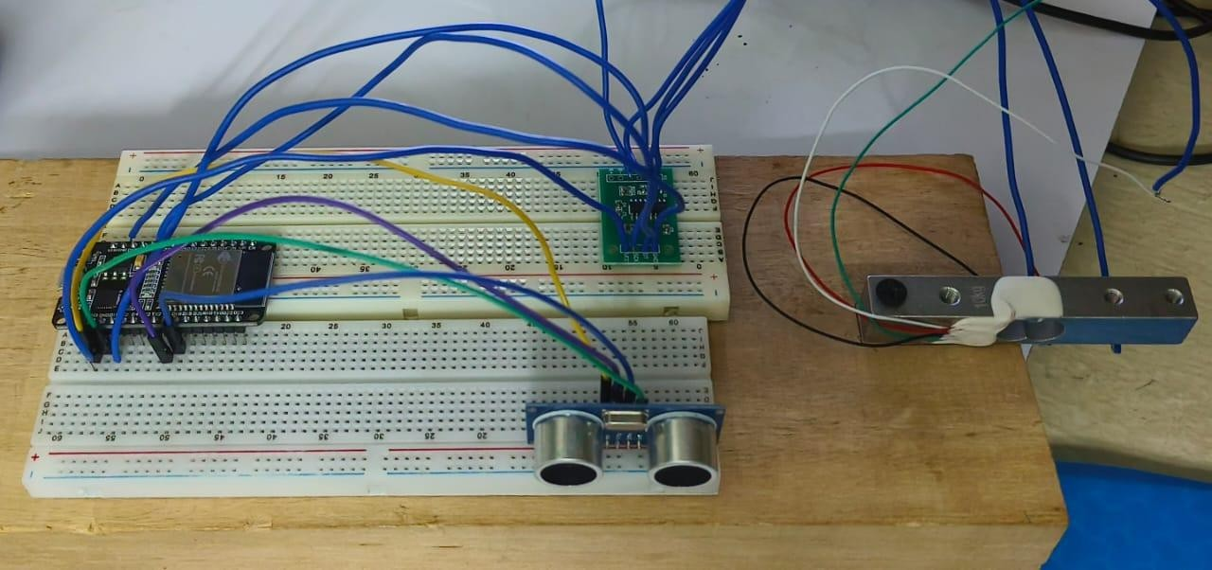

### Figure 5.1. Proposed System

The prototype model of the **Automatic BMI Detector** was successfully designed, and experimental tests were carried out by allowing individuals to stand on the load cell platform while the ultrasonic sensor measured their height. The **BMI was calculated** based on the measured weight and height using the ESP32 microcontroller. The calculated BMI value was displayed on the **Serial Monitor**, and an overall comment regarding the person’s body status (e.g., underweight, normal, overweight, or obese) was generated. These results were compared with manually calculated BMI values to verify the **accuracy** of the system. The device demonstrated reliable performance and could serve as a **simple, low-cost alternative** to traditional BMI measurement methods.

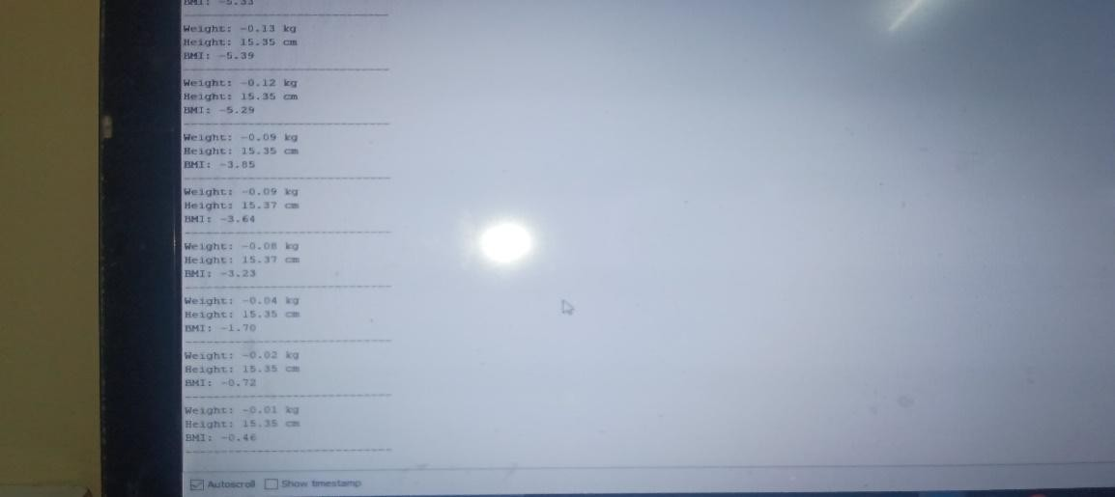

**Figure 5.2. Output In Serial Monitor**

# CHAPTER 6

**CONCLUSION AND FUTURE ENHANCEMENT**

In conclusion, this mini mini project, an Automatic BMI Detector was successfully developed using the ESP32 microcontroller, HX711 load cell sensor, and ultrasonic sensor. The system effectively calculates the Body Mass Index (BMI) by measuring both the weight and height of an individual. The HX711 load cell sensor provides an accurate reading of the user’s weight, while the ultrasonic sensor measures the height by calculating the time taken for the sound waves to reflect off the user. The ESP32 microcontroller processes this data and computes the BMI using the standard formula: weight (kg) divided by height squared (m²).The system continuously outputs the measurements of weight, height, and BMI via the Serial Monitor, while the onboard LED blinks to indicate that the system is operating. This simple yet effective approach allows for real-time health monitoring and provides a solid foundation for further enhancements, such as adding a display, cloud integration, or improving sensor accuracy. The mini project demonstrates how inexpensive components like sensors and microcontrollers can be combined to create a practical tool for health-related applications, highlighting the potential for developing affordable and portable health monitoring systems..

FUTURE WORKS

While the current version of the Automatic BMI Detector provides basic functionality for weight and height measurement, there are several potential improvements and future enhancements that can be made to expand its capabilities. Display Integration: One of the key improvements would be to integrate an LCD or OLED display to show the BMI, weight, and height values directly on the device.

This would eliminate the need to rely on a computer for real-time feedback.

Data Logging and Cloud Integration: The system can be upgraded to log measurements over time and send the data to a cloud platform or mobile application. This would allow users to track their BMI changes and health progress over weeks or months. Integrating with cloud services such as Google Firebase or ThingSpeak can provide a more accessible way for users to monitor their health remotely.

More Accurate Sensors: Although the ultrasonic sensor provides a decent approximation for height, using more precise sensors like a laser distance sensor or an infrared sensor could improve the accuracy of height measurement. Additionally, improving the calibration of the load cell sensor could lead to more precise weight readings.

User Interface (UI): A more sophisticated user interface (UI), perhaps using a touch screen or a mobile app, could make the system more user-friendly. It would allow users to input additional information such as age, gender, or activity level, which could be used to provide more tailored health recommendations.

Battery-Powered Operation: Currently, the system relies on a continuous USB connection for power. In the future, the mini project could be modified to operate battery-powered with low-power consumption techniques, allowing the device to be more portable and usable in various environments without the need for an always- on power source.

Health Recommendations and Alerts: Incorporating additional software algorithms to give health recommendations based on BMI readings could be a valuable next step. For example, the system could suggest diet and exercise changes or alert the user if their BMI falls into an unhealthy range. This would enhance the overall functionality and make the system more interactive and useful for health monitoring.

# REFERENCES

* Białecki, L., et al. Obesity Paradox and Coronary Artery Disease: A Review of Calcium Score Findings in Obese Patients. Journal of Cardiovascular Research, 202X.
* Weerts, J., et al. BMI and Heart Failure Risk in Women: Strategic Treatment Approaches. International Journal of Cardiology, 202X.
* Hedrick, H., et al. User Interface Challenges in Digital BMI Calculators. Journal of Health Informatics, 202X.
* Flórez-Revuelta, F., et al. Scientific Validation of Mobile Health Applications: The Case of BMI Calculators. Digital Health Review, 202X.
* World Health Organization (WHO). Body Mass Index: A Global Health Indicator.WHO Publications, 202X.
* National Institute of Health (NIH). Obesity and Public Health: The Role of BMI Measurement
* Poirier, P., et al. (202X). "Obesity and Cardiovascular Disease: Pathophysiology, Evaluation, and Effect of Weight Loss." Journal of the American College of Cardiology.
* Zhao, Y., et al. (202X). "Exploring the Impact of BMI on Metabolic Health: A Data- Driven Study." Journal of Metabolic Health.
* Schroeder, S., et al. (202X). "The Role of BMI in Predicting Health Risks Across Different Populations." Global Health Insights.
* Wang, Y., et al. (202X). "The Relationship Between BMI and Chronic Diseases: A Review." International Journal of Obesity.
* Fraser, W.D., et al.